### **1. Burnout Rate (Histogram)**

* **What it shows**:  
  A histogram visualizing the distribution of employees' Work_Life_balance scores, helping identify the most common levels of burnout.
* **Purpose**:  
  To understand how work-life balance varies across the workforce and highlight patterns in burnout rates.

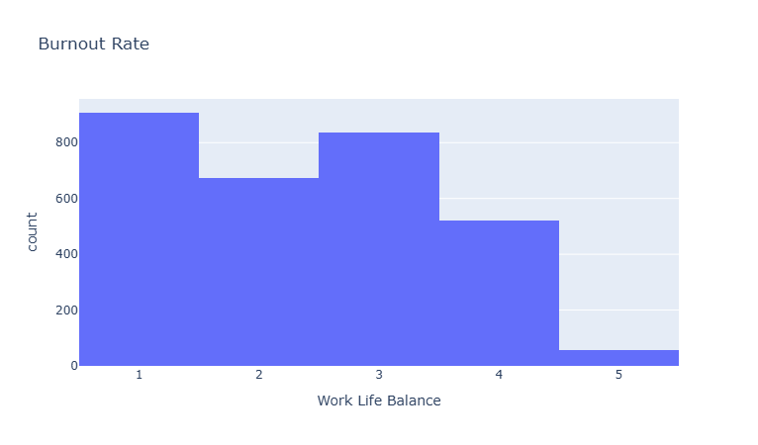

### 

### 

### 

### 

### 

### 

### 

### **2. Workload vs. Burnout Level (Scatter Plot)**

* **What it shows**:  
  A scatter plot that maps Time_of_service (workload proxy) against Work_Life_balance, with color intensity representing burnout levels.
* **Purpose**:  
  To observe how the length of service correlates with work-life balance and identify high-risk groups based on tenure.

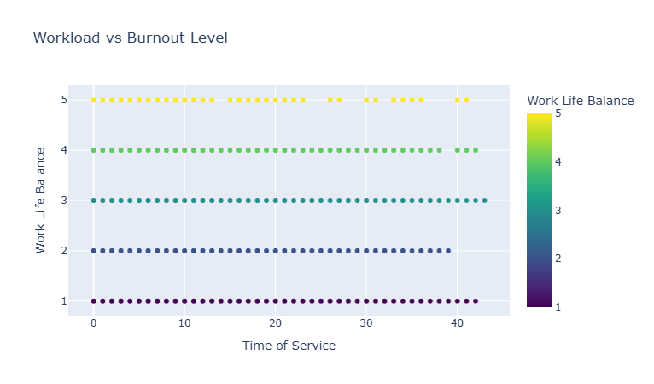

### **3. Burnout by Gender (Histogram)**

* **What it shows**:  
  A histogram that compares burnout levels (Work_Life_balance) across different genders.
* **Purpose**:  
  To detect gender-based disparities in burnout and support targeted interventions for equality.

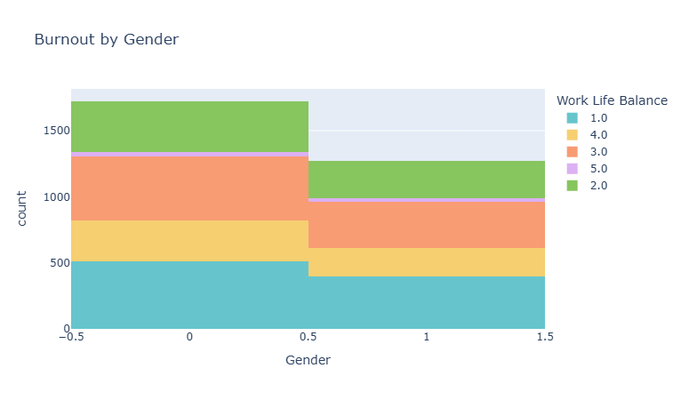

### **5. Burnout Trends by Seniority (Line Graph)**

* **What it shows**:  
  A line graph plotting Time_of_service against Work_Life_balance, with trends broken down by burnout level.
* **Purpose**:  
  To analyze how burnout changes with job seniority and pinpoint critical points for intervention.

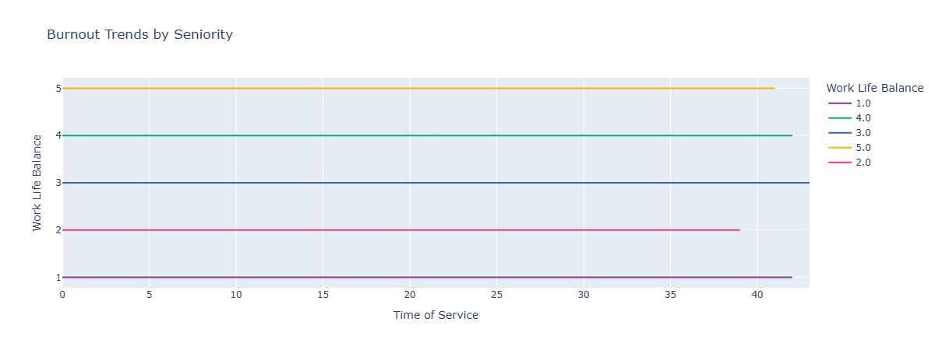

### 

### 

### 

### 

### 

### 

### 

### 

### 

### 

### **6. Heatmap of Correlations (Heatmap)**

* **What it shows**:  
  A heatmap visualizing the correlations between numeric features like Age, Time_of_service, and Work_Life_balance.
* **Purpose**:  
  To uncover relationships between variables and identify key factors influencing burnout.

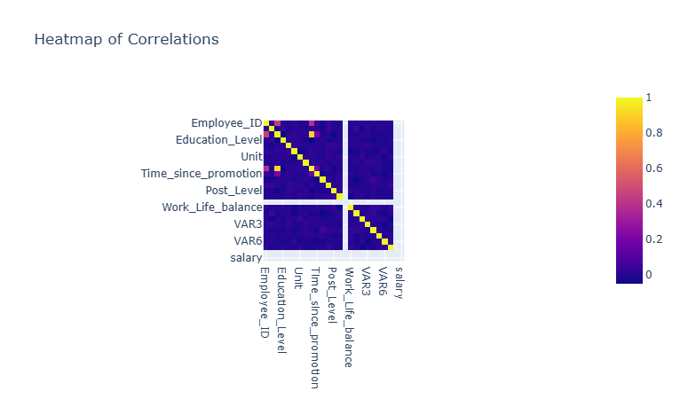

### **7. Top 5 Burnout Risk Factors (Bar Chart)**

* **What it shows**:  
  A bar chart highlighting the five most influential factors for predicting Work_Life_balance, based on feature importance from the Random Forest model.
* **Purpose**:  
  To guide HR strategies by prioritizing interventions in areas with the highest burnout impact.

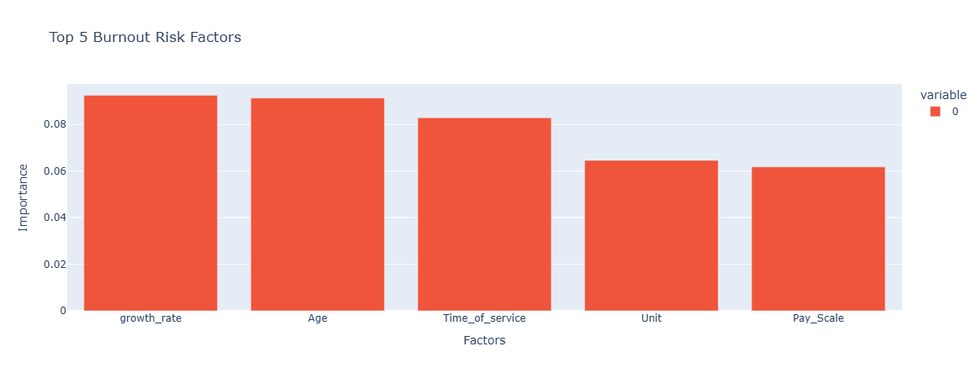

### **8. Burnout by Department (Bar Chart)**

* **What it shows**:  
  A bar chart showing the average Work_Life_balance scores for different departments (Unit).
* **Purpose**:  
  To evaluate departmental variations in burnout and target improvements where needed.

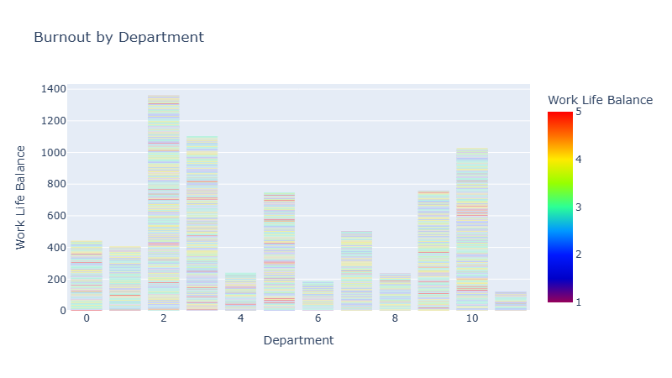

### 

### 

### 

### 

### 

### 

### 

### 

### **9. Burnout by Job Level (Box Plot)**

* **What it shows**:  
  A box plot depicting the spread of burnout levels (Work_Life_balance) across different job levels (Post_Level).
* **Purpose**:  
  To analyze how job roles and responsibilities influence burnout levels.

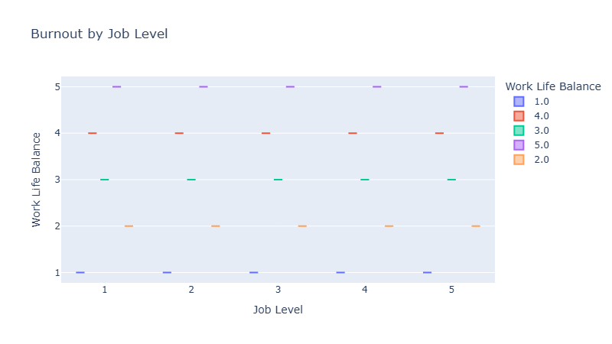

### **10. Work Hours vs. Burnout (Scatter Plot)**

* **What it shows**:  
  A scatter plot examining the relationship between Time_of_service (work hours proxy) and Work_Life_balance.
* **Purpose**:  
  To explore how increasing work hours correlate with burnout.

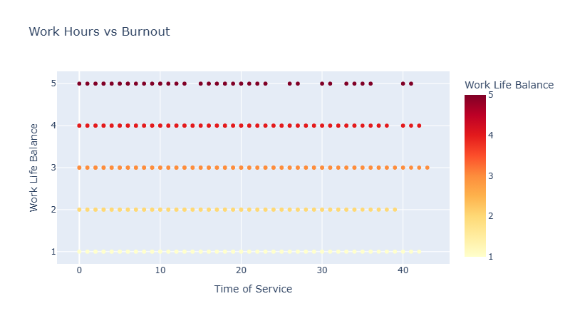

### 

### 

### 

### 

### 

### 

### 

### 

### 

### 

### **11. Burnout Distribution by Work-Life Balance (Pie Chart)**

* **What it shows**:  
  A pie chart showing the proportion of employees at different levels of Work_Life_balance.
* **Purpose**:  
  To give a quick overview of how many employees are thriving versus struggling in terms of work-life balance.

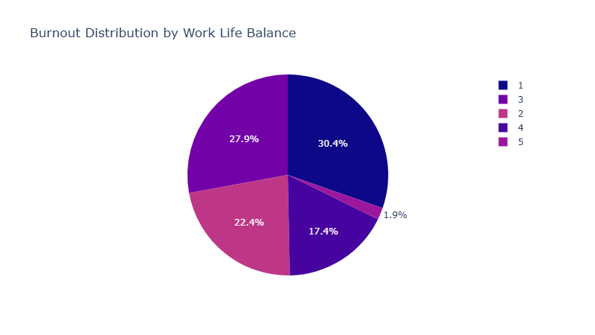

**12. Burnout by Age (Histogram)**

**Purpose**: Displays how burnout levels vary across different age groups, helping identify age-specific vulnerabilities.  
**Code Reference**: burnout_by_age in /dashboard.

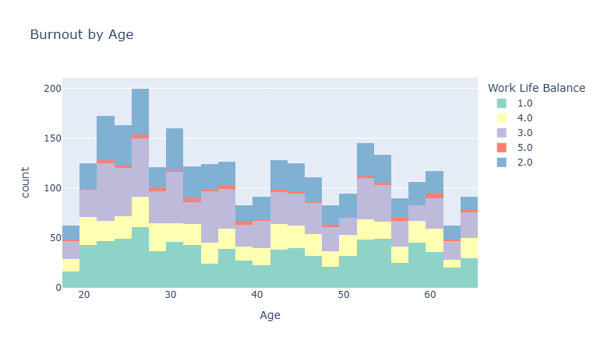

**13. Burnout Trends by Seniority (Line Graph)**

**Purpose**: Illustrates how burnout levels change with seniority, highlighting trends related to employees' time in service.  
**Code Reference**: burnout_trends_by_seniority in /dashboard.

